May 1, 2006
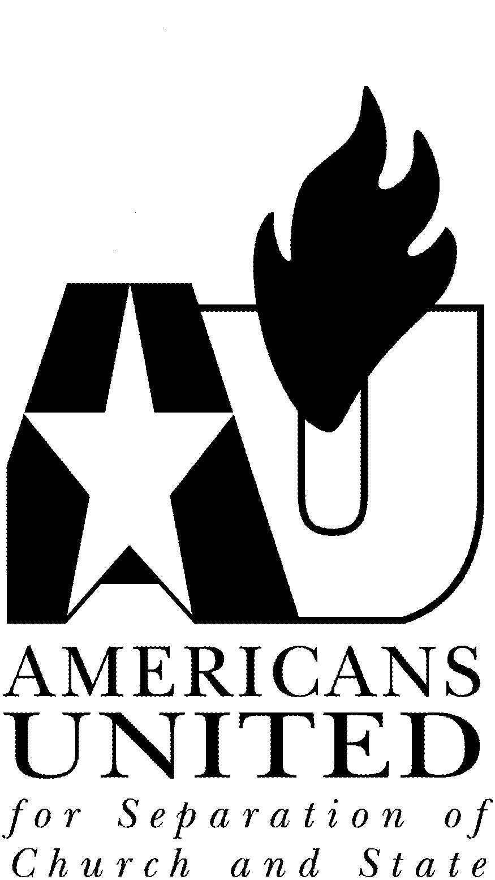

National Office

518 C St., N.E.

Washington, D.C. 20002

(202) 466-3234

(202) 466-2587 fax

americansunited@au.org

www.au.org

PROTECT THE INTEGRITY OF THE FIRST AMENDMENT AND
OPPOSE S. J. RES. 12, THE FLAG DESECRATION AMENDMENT

Dear Senator:

Americans United for Separation of Church and State urges you to oppose the Flag Desecration Constitutional Amendment (S. J. Res 12) because it would undermine fundamental rights and freedoms contained in the First Amendment of the U.S. Constitution. Americans United represents more than 75,000 individual members throughout the fifty states, 9,500 clergy nationwide, as well as cooperating houses of worship and other religious bodies committed to the preservation of religious liberty.

With the upcoming consideration of the Flag Desecration Amendment, the Senate stands poised to significantly harm the First Amendment of the U.S. Constitution. S. J. Res. 12 would constitute the first time in American history that the Constitution would be restricted in order to suppress core political expression, long protected by the First Amendment, that is so central to vigorous debate and personal expression in our democracy. It would also set an exceedingly dangerous precedent for further erosion of our fundamental constitutional freedoms. The Senate should leave the First Amendment intact and avoid tinkering with the Constitution for short-term political benefit.

The proposed amendment would do irreparable damage to the rights of Americans. Proponents of the proposed constitutional amendment contend that they want to “honor” the American flag. Yet by attempting to alter the First Amendment, they would deeply undermine the integrity of the American Constitution. Removing constitutional protection from core political expression simply because it gives offense to others would constitute grave damage to our nation’s founding principles and fundamental freedoms.

S. J. Res. 12 also is inconsistent with the ideals of the Establishment Clause in the First Amendment. The text of the proposed Amendment prohibits the physical “desecration” of the American flag. The term “desecration” has traditionally been used to define attacks on religious symbols and holy books. Indeed, Webster’s New World Dictionary, 3d College Edition, defines “desecrate” as: “tak[ing] away the sacredness of; [or] treat as not sacred.” Although the flag is an important civic symbol of our nation, it has no religious meaning. To ensconce in the body of the Constitution language that prohibits desecrating the United States flag would thus place the federal government in the role of deeming the flag as officially sacred. Proponents of the proposed Amendment are investing the flag with religious meaning it lacks.

Americans United is keenly aware that the United States flag is a cherished symbol of America’s history and Americans’ shared liberties. But, as members of the Supreme Court from a wide-ranging ideological spectrum noted in Texas v. Johnson - in which the Court found that the burning of the American flag constitutes expressive
conduct, freedom of expression is a core protection among Americans’ most cherished rights, even if that expression is offensive. Justices Brennan, in delivering the opinion of the Court, in which Justices Marshall, Blackmun, Scalia, and Kennedy joined, noted:

We are tempted to say . . . that the flag’s deservedly cherished place in our community will be strengthened, not weakened, by our holding today. Our decision is a reaffirmation of the principles of freedom and inclusiveness that the flag best reflects, and of the conviction that our toleration of criticism such as Johnson’s is a sign and source of our strength . . . It is the Nation’s resilience, not its rigidity, that Texas sees reflected in the flag – and it is that resilience that we reassert today.

Texas v. Johnson, 491 U.S. 397, 419 (1989). The Court went on to note that “[w]e do not consecrate the flag by punishing its desecration, for in doing so we dilute the freedom that this cherished emblem represents.” Id. at 420. Justice Kennedy, writing along similar lines, noted in a concurring opinion that “the flag is constant in expressing beliefs Americans share, beliefs in law and peace and that freedom which sustains the human spirit. The case here today forces recognition of the costs to which those beliefs commit us. It is poignant but fundamental that the flag protects those who hold it in contempt.” Id. at 421 (Kennedy, J., concurring). The very heart of the fundamental constitutional guarantee to express one’s views would be deeply undermined if the Flag Desecration Amendment were to become law.

The Bill of Rights has not been amended since its ratification and should be left intact. Passage of the proposed Amendment would create a dangerous precedent for future alterations to the Bill of Rights, especially given the goals among many proponents of S. J. Res. 12 to support numerous other restrictions of Americans’ fundamental constitutional freedoms through other constitutional amendments. Congress should avoid attempting to make a holy icon out of the American flag, should stay out of the business of imposing an orthodoxy of political views on the American public, and should soundly reject passage of this proposed Amendment.

If you have any questions about S. J. Res. 12 or would like further information on any other issue of importance to Americans United, please contact Aaron D. Schuham, Legislative Director, at (202) 466-3234, extension 240.

Sincerely,

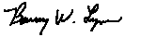
Rev. Barry W. Lynn
Executive Director

